TASK 2
BY FERDAUS
WordPress Admin Dashboard
Back-End Technical Plan — Back-End / React Admin

Overview:-
This document explains how the admin dashboard is implemented for managing todos. The admin panel allows viewing, adding, editing, and deleting todos without page reload.

Both the admin panel and frontend block use the same REST API and database table, so data remains consistent.

Plugin File Structure:-

Suppose My Admin Specific Folder Layout:

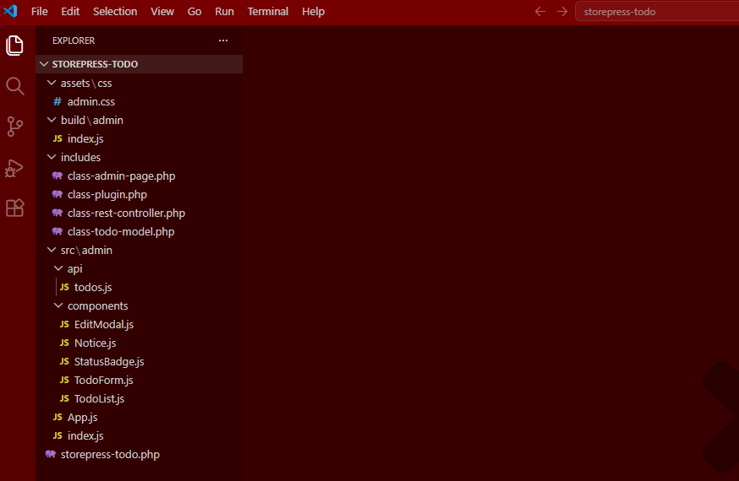

File Details:
File | Responsibility
class-admin-page.php | Registers the admin menu and loads the React
src/admin/index.js | Mounts the React app into the admin page. ReactDOM.
src/admin/App.js | Handles global state and loads todos when the page initializes.
components/TodoList.js | Maps over todos, renders row with title, status, Edit/Delete buttons
components/TodoForm.js | Controlled form submits createTodo(), ADD to state
components/EditModal.js | Opens on Edit click PUT request on save, UPDATE to state
api/todos.js | All HTTP calls apiFetch. Like fetchTodos, createTodo, updateTodo, deleteTodo

Data Collect:- Task 1 <-> Task 2
Both frontend and admin use the same REST API endpoints and database table. This means any change made in one place will be reflected everywhere on the next load.

Frontend Block (Task 1) | < | REST APIstorepress/v1 | < | wp_sp_todos(DB Table) | < | Admin Panel (Task 2)

Real Time Consistency, Because both interfaces write through the REST API to the same table, any todo created/edited/deleted in admin shows up on the frontend on the next page load and vice versa. No caching layer, no data required.

Admin Page Registration:-

Menu Registration (class-admin-page.php)
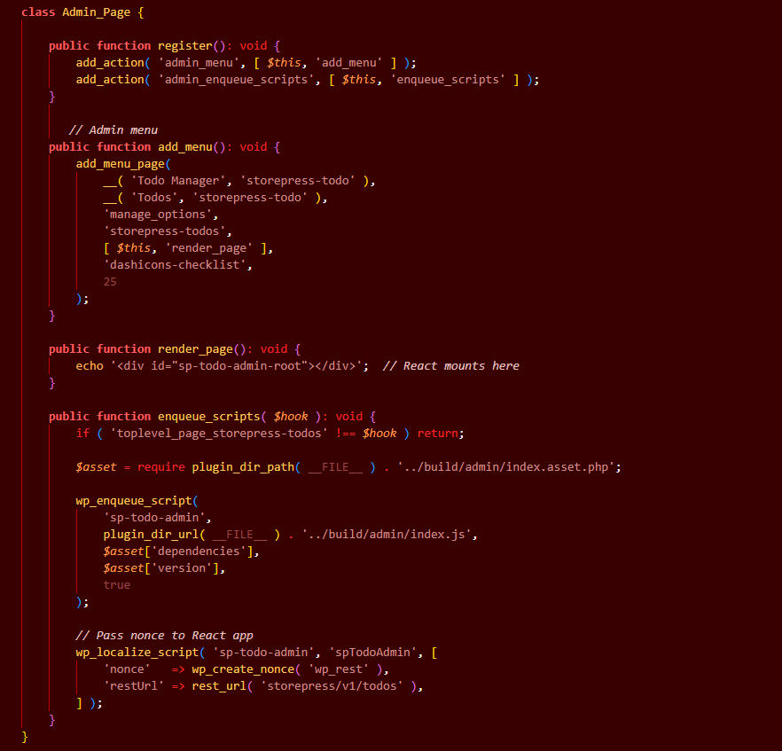

State Manage:- WP or React

Pattern: @wordpress/data or useReducer + useContext
The admin uses React's built in useReducer combined with useContext to share state across all components. No external library is needed for this scope. It keeps the bundle lean and the code idiomatic.

State Shape:
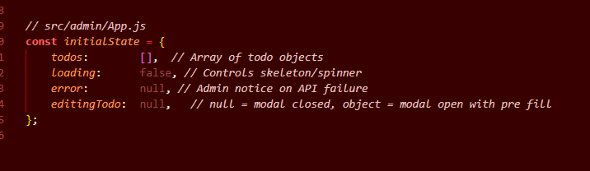

Reducer:
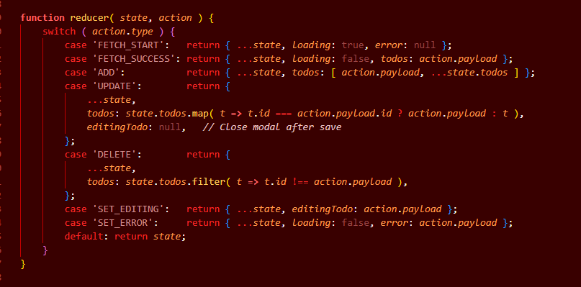

Context Provider (App.js):
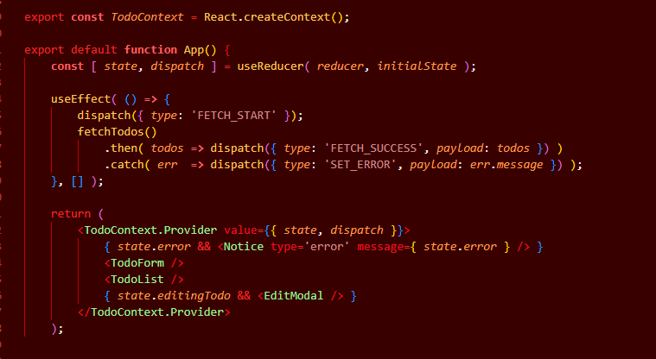

HTTP Layer:-
All HTTP operations in the admin use @wordpress/api-fetch WordPress official fetch wrapper. It is never acceptable to use raw fetch() in WordPress admin interfaces.

Why api-fetch?
Raw fetch() | @wordpress/api-fetch
Must manually attach nonce header | Auto attaches WP Nonce via middleware
Hard code REST URL | Resolves root URL automatically
No middleware support | Supports custom middleware
Not WordPress native | Official WP package

API Module (api/todos.js):

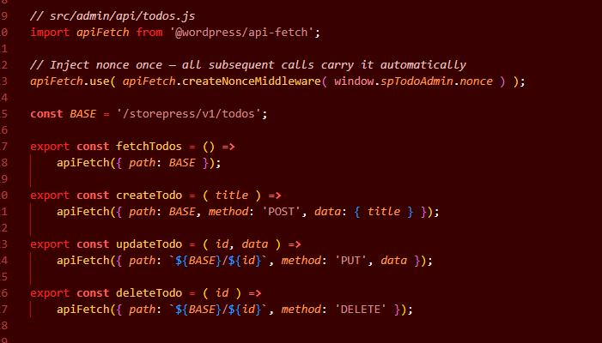

Add / Edit / Delete:- No Page Reload

Add New Todo (TodoForm.js):
A form sits at the top of the admin page. On submit it calls createTodo() apiFetch, then dispatches ADD to state the new item appears at the top of the list instantly without any page reload.

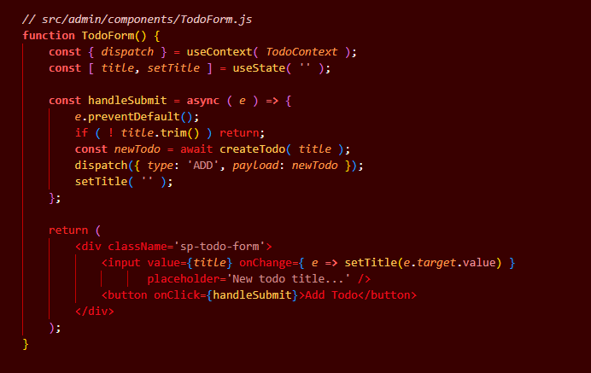

Edit Todo (EditModal.js):
User opens modal then updates value then API call then state updated
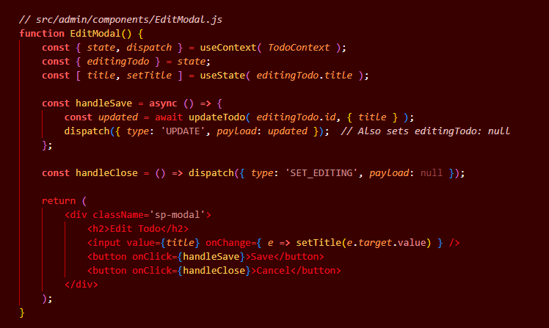

Delete Todo (TodoList.js):
User confirms then API call then item removed from state. Then the row is removed from state immediately. No page reload needed.
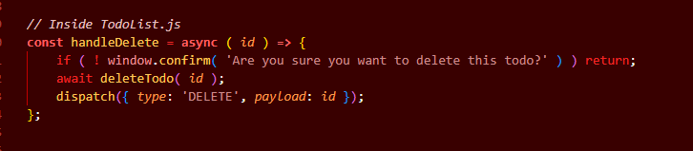

Actions Summary:
Action | UX Behaviour | State Dispatch
Add | Submit form item appears at top of list instantly | dispatch({ type: 'ADD', newTodo })
Edit | Click Edit > modal opens pre filled > Save > row updates | dispatch({ type: 'UPDATE', updatedTodo })
Delete | Click Delete > confirm prompt > row removed from list | dispatch({ type: 'DELETE', id })

Security:-
Layer | Implementation
Nonce | wp_create_nonce() in PHP > wp_localize_script > apiFetch
Capability | add_menu_page uses manage_options only admins see the page
Permissions | REST permission_callback for DELETE
Sanitization | sanitize_text_field() for title in REST controller
Script Scope | Admin bundle only enqueued on the plugin's own admin page

Error Handling:-
Every API call in the admin panel has a defined failure path. The admin should never see a blank screen, broken state, or silent failure. Errors are surfaced through WordPress style admin notices.

Error Types & Admin Responses
Error Type | HTTP Code | Admin Response
Network failure | ………. | Request failed. Check your connection. + state rollback
Session expired | 401 | Notic 'Your session has expired.'
Forbidden | 403 | Notice 'You do not have permission.'
Not found | 404 | Remove stale row from state silently
Validation error | 422 | Inline field error below the input
Server error | 500 | Server error. Please try again. + full state

Global Error (Admin):

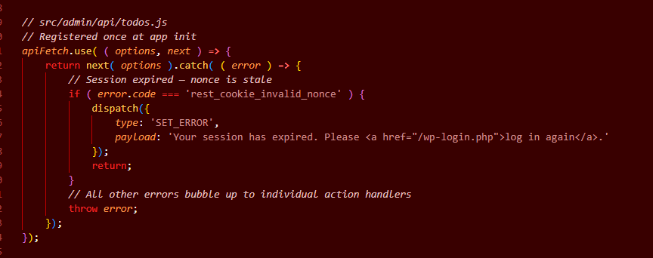

Notice Component:

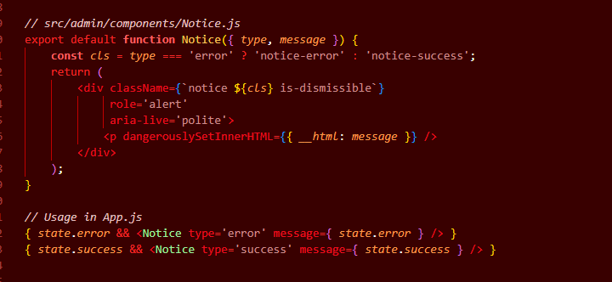

Scalability:-
The admin panel is designed to handle large datasets and real world edge cases gracefully not just the happy path.

Pagination in Admin Table:
When there are hundreds or thousands of todos, the admin table uses server side pagination matching the same pagination parameters supported by the REST API.
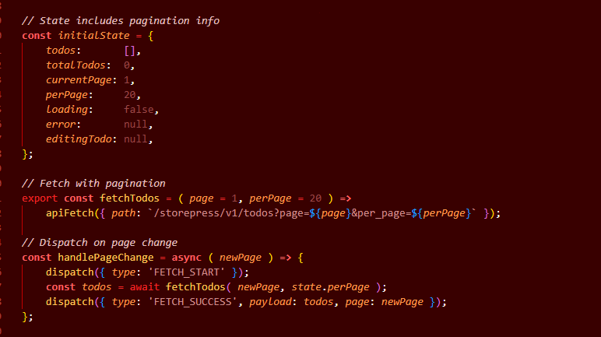

Edge Cases Handled:
Edge Case | How It's Handled
Admin edits todo while another tab deletes it | REST returns 404 > dispatch UPDATE fails silently
Empty todo title on submit | Button disabled while input is empty
Admin clicks Delete quickly | Button disabled immediately after first click prevents duplicate DELETE calls
Bulk todos | Paginated API + paginated table never loads all records at once
User navigates away mid edit | EditModal state is in React closing tab or navigating discards unsaved changes
Plugin deactivation | Data preserved only uninstall hook drops the table
Non admin accesses admin page | WordPress capability check blocks access at the menu level

Performance Admin Bundle Size:
The admin React bundle is only enqueued on the plugin's own admin page. A strict $hook check in the enqueue function prevents it from loading on any other admin screen.

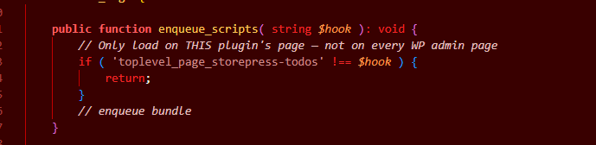Testing:-
The admin panel is tested at three levels unit, integration, and end to end to catch regressions early and verify the full user flow.

Strategy:
Level | Tool | What Is Tested
PHP | Unit + WP Test | REST controller: create, update, delete, permission checks
React | React Testing | TodoForm submit, Edit Modal open/close
Integration | WP + PHP | admin_menu registration, script enqueue on correct hook only
End to End | WP e2e utils | Admin logs in > adds todo > edits it > deletes it

Sample React Component:

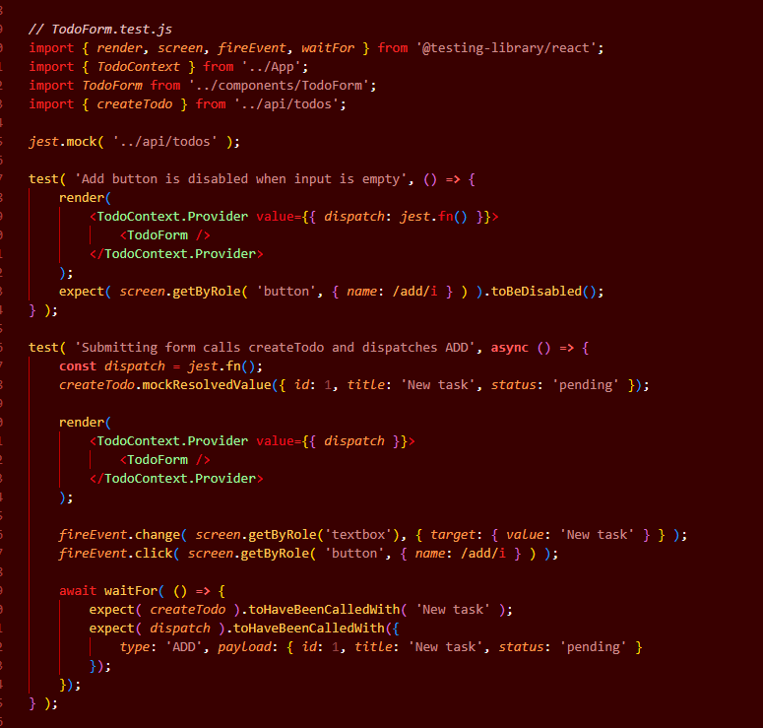

Tech Stack Task 2:
Layer | Technology
Admin Page | add_menu_page() WordPress native admin menu
Frontend UI | React compiled @wordpress/scripts
State Management | useReducer + useContext no external library
HTTP Client | @wordpress/api-fetch WP native, auto nonce
REST Layer | Same WP_REST_Controller as Task 1
Database | Same $wpdb custom table as Task 1 one source of truth
Security | manage_options check, nonce wp_localize_script

